Tritech Diver Mounted Display
Navigation and inspection in zero visibility conditions
The Diver Mounted Display (DMD) system has been designed to provide divers with the ability to navigate and carry out inspections in zero visibility conditions.
Utilising the Gemini range of Multibeam imaging sonars allows the user to select the most suitable sonar for the type of operation required. The world’s smallest Multibeam imaging sonar, the Gemini 720im, provides a basic navigation capability, allowing a diver to locate large structures or objects while working in zero visibility water.
Where a higher degree of resolution is required the diver can opt for the Gemini 720ik or Gemini 1200ik Multibeam imaging sonar, both of which provide increased range, resolution and field of view. These high specification Multibeam imaging sonars provide a diver with a high degree of confidence while working in zero visibility conditions and allow searches to be undertaken far more efficiently than using conventional search pattern techniques.
The DMD systems have been designed to be used with the Inodive accessory rail system, allowing for the DMD system to be used with an extensive range of dive masks and helmets. All of the Gemini sonars, when supplied with a DMD system, are built-up with an Inodive interface to allow for seamless installation onto the dive mask/helmet.
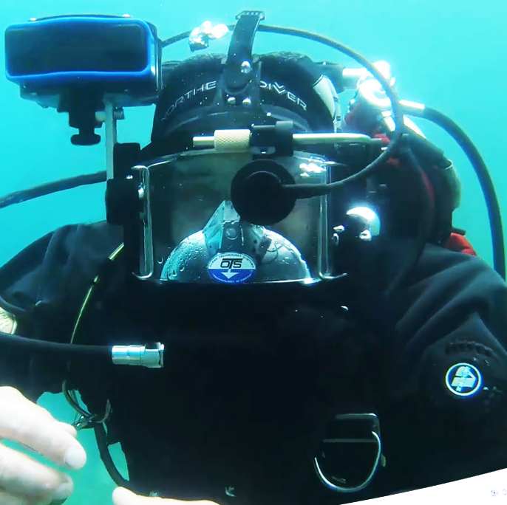
Diver Mounted Display (DMD) system enables divers to navigate and carry out inspections in zero visibility conditions.
Read More
Tritech Diver Mounted Display
[upload PDF]

